# Web Layers Explored: The Depths of the Internet

Clearnet, Surface Web, Bergie Web, Deep Web, Darknet, Private Web, Marianas Web

August 1, 2023

[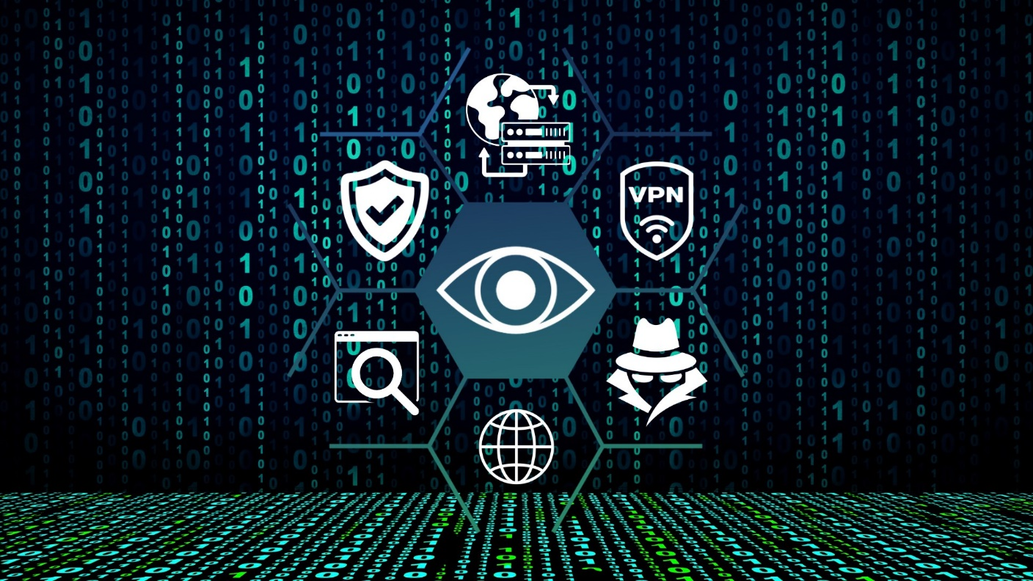](https://user-images.githubusercontent.com/131223318/259529013-d202deac-09e1-419a-ade1-0ebb66fc3683.jpg)

In the age of boundless connectivity, the internet has become an indispensable facet of modern life, woven intricately into the fabric of our daily routines. From conducting research and connecting with loved ones to shopping for the latest trends, the World Wide Web offers a vast and diverse landscape of possibilities at our fingertips. However, beyond the familiar realms of search engines and social media lies an enigmatic world, shrouded in mystery and myth, the hidden layers of the internet.

We will embark on an exploratory journey to demystify these hidden realms, uncovering the secrets of Clearnet, Deep Web, Darknet, and more. As we navigate through this digital labyrinth, we will unravel the complexities and shed light on the lesser-known corners of the web, gaining a deeper understanding of the internet's multifaceted nature. So, fasten your virtual seatbelts and prepare to embark on a thrilling quest through the internet's hidden depths, where knowledge, privacy, and intrigue converge.

## Clearnet

In the vast expanse of the internet lies Clearnet, a web layer synonymous with the Open Web or Public Web. As the visible face of the internet, Clearnet encompasses the entirety of websites and content indexed and accessible through conventional search engines like Google, Bing, and Yahoo. Here, the digital landscape thrives with a diverse array of websites, ranging from the world's most popular social media platforms and e-commerce giants to informative blogs and news portals. Accessibility is the hallmark of Clearnet, as users worldwide can freely browse, explore, and interact with its wealth of information without any specialized tools or permissions.

The transparency of Clearnet not only facilitates ease of access but also plays a vital role in shaping modern society. Businesses leverage the platform to establish their online presence, fostering global connections and attracting audiences from all corners of the world. For individuals, Clearnet serves as an unparalleled gateway to knowledge, enabling continuous learning and discovery across an array of topics. Yet, beneath the surface of this seemingly boundless openness, lies an intricate web of security protocols and ethical considerations. As users revel in the freedom of exploration, they must remain mindful of safeguarding their privacy and adhering to responsible online practices. Clearnet, while a beacon of connectivity and knowledge, reminds us of the importance of striking a delicate balance between accessibility and digital responsibility in the modern age.

## Surface Web

Beneath the familiar expanse of the internet's Surface Web lies a vast digital world brimming with information, commerce, and interconnectedness. Often used interchangeably with Clearnet, the Surface Web represents the visible tip of the internet iceberg, the portion that is indexed and readily accessible to the millions of users across the globe. Here, the online landscape thrives with an astonishing diversity of websites, ranging from popular news portals and e-commerce giants to educational resources and entertainment platforms. Social media networks echo with the chatter of billions, and content creators share their insights, sparking conversations that resonate worldwide. The Surface Web's hallmark lies in its openness, welcoming users with open arms to explore and discover the wonders of the digital realm.

Yet, behind this facade of accessibility lies a curated selection of what the internet has to offer. The Surface Web is akin to an expertly curated library with well-organized shelves, showcasing content deemed suitable for public consumption. With search engines as gatekeepers, users are provided a seemingly endless array of possibilities, catering to their interests and inquiries. However, it is crucial to recognize that the Surface Web represents only a fraction of the internet's total content. Hidden in the shadows of this visible landscape lie the unindexed and unexplored corners of the Deep Web and the clandestine realms of the Darknet. As we delve deeper into the digital landscape, we shall uncover the intricate web of web layers, understanding how they complement and contrast with one another in shaping the internet we traverse daily.

## Bergie Web

Tucked away in the obscure corners of the Surface Web, lies an enigmatic web layer that defies conventional norms, the elusive Bergie Web. Often evading the spotlight, Bergie Web emerges momentarily like fleeting apparitions, existing for only a brief period before vanishing into the digital ether. This transient nature sets it apart from its more prominent counterparts, such as the Deep Web and Darknet, rendering it an intriguing yet often overlooked aspect of the internet's ever-evolving landscape.

The ephemeral essence of Bergie Web is not without purpose. It serves as a temporary harbor for websites and content that are designed to flourish in the digital wilderness briefly. From short-term campaigns and clandestine activities to transient online markets, this ethereal layer caters to a myriad of purposes, both legitimate and malicious. However, the very volatility that grants Bergie Web its unique charm also poses challenges for researchers and authorities seeking to monitor and comprehend its fluid nature. As we embark on an expedition to unearth the mysteries of Bergie Web, we uncover its ephemeral allure and navigate the digital realm's transient underbelly, shedding light on this captivating but elusive facet of the internet.The ephemeral essence of Bergie Web is not without purpose. It serves as a temporary harbor for websites and content that are designed to flourish in the digital wilderness briefly. From short-term campaigns and clandestine activities to transient online markets, this ethereal layer caters to a myriad of purposes, both legitimate and malicious. However, the very volatility that grants Bergie Web its unique charm also poses challenges for researchers and authorities seeking to monitor and comprehend its fluid nature.

## Deep Web

Enveloped in secrecy, the Deep Web defies the reach of conventional search engines, existing beyond the purview of Google and Bing. Here, behind login screens and encrypted walls, lies a vast repository of valuable information, private databases, and protected content. The Deep Web encompasses various resources, from academic databases and corporate intranets to subscription-based platforms and confidential government archives. Far from the illicit activities often associated with the Darknet, the Deep Web primarily serves as a secure haven for safeguarding sensitive data and protecting individual privacy.

Navigating the Deep Web requires an entirely different approach than the surface-dwelling Clearnet. While the latter openly welcomes users with a wealth of accessible information, the Deep Web demands credentials and specific permissions for entry. The realm's dedication to privacy and security comes with ethical considerations as users are urged to respect boundaries and adhere to responsible practices while exploring its hidden depths.

## Darknet

The Darknet represents a subset of the Deep Web, where websites exist in the shadows, accessible only through specialized software like Tor. Unlike the Surface Web and Clearnet, which celebrate openness and accessibility, the Darknet operates in the realm of anonymity and discretion. Its primary allure lies in offering users a cloak of digital invisibility, allowing them to communicate and transact without leaving behind a digital trail. However, this veil of anonymity also fosters a hidden underbelly where illegal activities, such as black markets, cybercrime, and illicit services, often thrive.

The Darknet requires caution, when navigating, and a firm understanding of ethical implications. While some individuals seek refuge from surveillance and censorship in this anonymous realm, others exploit the lack of accountability for nefarious deeds. As we peer into the darkness of the Darknet, we uncover its duality, a dichotomy between those who value digital privacy and those who exploit it for malicious purposes. While it is essential to grasp the complexities of the Darknet, it is equally vital to remember the responsibility that comes with this unprecedented level of anonymity, urging users to tread carefully while respecting the boundaries of legal and ethical conduct on the internet's enigmatic side.

## Private Web

Amidst the intricate layers of the internet stands, an ethical oasis in a world of openess, the Private Web. Confidentiality is fostered and sensitive information is safeguarded within this web sector. Unlike the often-elusive Darknet or the transient Bergie Web, the Private Web refers to a collection of web pages, databases, and platforms that are intentionally secured with layers of encryption and access controls. Commonly found in corporate environments, private organizations, and personal spaces, these secluded corners of the internet prioritize data protection and privacy, catering to a select audience with restricted access.

The Private Web serves as a bastion for confidential exchanges, from internal communications and proprietary research to classified government information and personal documents. By employing stringent security measures, such as passwords, firewalls, and encryption protocols, individuals and organizations can ensure that their data remains inaccessible to unauthorized users.

## Marianas Web

In the realm of internet folklore, the legend of the "Marianas Web" has captured the imaginations of many, promising access to a fabled layer that transcends the boundaries of the Deep Web and the Darknet. Often described as the deepest and darkest stratum of the internet, the Marianas Web is said to be an elusive domain harboring classified information, AI superintelligence, and unimaginable secrets that surpass the comprehension of ordinary users. Despite the allure of this digital abyss, it is essential to dispel the myths surrounding the Marianas Web, as it stands as a fictional concept with no basis in reality.

The origin of the term "Marianas Web" traces back to a speculative internet myth, akin to urban legends that circulate in the digital age. It draws inspiration from the Mariana Trench, the deepest part of the world's oceans, an analogy employed to evoke a sense of mystique and inaccessibility. While the internet is indeed a vast and intricate network with its own hidden layers, such as the Deep Web and Darknet, there is no credible evidence or substantiation for the existence of a mythical Marianas Web.

## Reflecting

In this blog post, we embarked on a captivating journey through the diverse web layers that constitute the internet's complex tapestry. We unraveled the mysteries of Clearnet, the open gateway to information, and navigated the Surface Web's familiar terrain, exploring the wealth of content indexed by search engines. Venturing into the hidden realms of the Deep Web, we discovered its crucial role in safeguarding sensitive data and fostering privacy, far from the misconceptions often associated with the Darknet. The transient nature of Bergie Web reminded us of the internet's ever-evolving landscape, where short-lived digital apparitions leave an ephemeral mark. In our quest to unmask the Marianas Web, we distinguished fact from fiction, recognizing the need to ground our understanding of the internet in reality.

As our journey comes to a close, one overarching theme emerges, the internet is an intricate ecosystem, reflecting the diversity and complexity of the human experience. From unrestricted accessibility to carefully guarded privacy, from transparency to obscurity, each web layer offers a unique perspective on the digital universe. Our journey has underscored the importance of ethical conduct and responsible practices while traversing these digital landscapes. As internet users, we must strike a delicate balance between openness and privacy, embracing the vast resources of the Clearnet while respecting the boundaries of the Deep Web and Darknet. By cultivating digital awareness and mindfulness, we can navigate the internet with confidence, ensuring that we contribute positively to this vast interconnected realm.

# Resources:

* [[Click Here]](https://www.w3.org/) *World Wide Web (W3C)*
* [[Click Here]](https://www.acm.org/) *Association for Computing Machinery*
* [[Click Here]](https://www.cisecurity.org/insights/spotlight/cybersecurity-spotlight-the-surface-web-dark-web-and-deep-web) *Center for Internet Security (CIS): The Surface Web, Dark Web, and Deep Web*
* [[Click Here]](https://www.freecodecamp.org/news/what-is-web3/) *freeCodeCamp: What is Web3? The Decentralized Internet of the Future Explained (2021)*
* [[Click Here]](https://medium.com/nerd-for-tech/mysterious-side-of-the-internet-5d2a02e103b7) *Mysterious Side of the Internet by Jaydev Joshi (2021)*
* [[Click Here]](https://www.youtube.com/watch?v=8JGjnq5NySg) *I Explored EVERY Level of The Dark Web by Crypto NWO (2020)*
* [[Click Here]](https://en.wikipedia.org/wiki/Internet) *Wikipedia: Internet*
* [[Click Here]](https://en.wikipedia.org/wiki/Internet) *Mozilla MDN Web Docs: Who the web works*
* [[Click Here]](https://www.cs.cornell.edu/home/kleinber/networks-book/networks-book-ch13.pdf) *Cambridge University Press: The Structure of the Web (2010)*
* [[Click Here]](https://www.cs.cornell.edu/home/kleinber/networks-book/) *Networks, Crowds, and Markets: Reasoning About a Highly Connected World by David Easley and Jon Kleinberg*